Subject: “I love filling out forms!” - Said No One...Ever

Hi, (name).

Having to do a little extra work can be a huge deterrent to qualified prospects. Asking them to take five minutes to fill out a form is taking them from five minutes with family, friends or Netflix (I mean, c’mon… It is Netflix). Hot off the presses from Facebook, lead ads are now being tested.

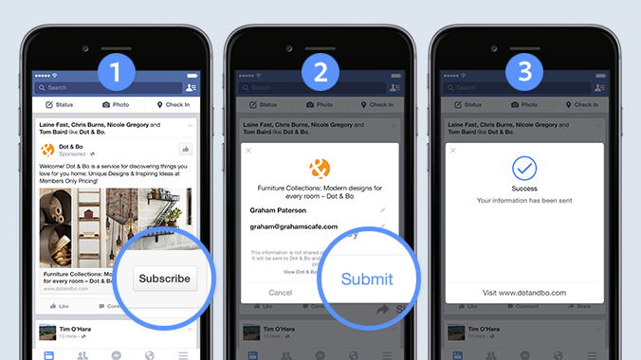

How are these types of ads going to help you? Glad you asked! Lead ads make the mobile signup process easier by automatically entering the contact information that is provided when a user signs up for Facebook, like email addresses. Facebook is currently testing different versions of lead ads that would let people sign up for things like newsletters, price estimates, follow-up calls and business information. This is cool stuff, (Name), and it’s only going to get better from here.

However, we do have some reservations about these types of ads. This is a similar type of setup that Twitter Cards used, which did not prove to provide a return on investment. This is because many people use an old email address to register for social media networks because they don’t want extra emails flooding their inbox. So chances are, if they sign up, you’re never going to hear from them again. In the meantime, (Name), we’ll be monitoring these ads to see how they perform. Want to read more about Facebook lead ads? Click here for the full article.

Focusing on the ROI,
Kim Walsh-Phillips

